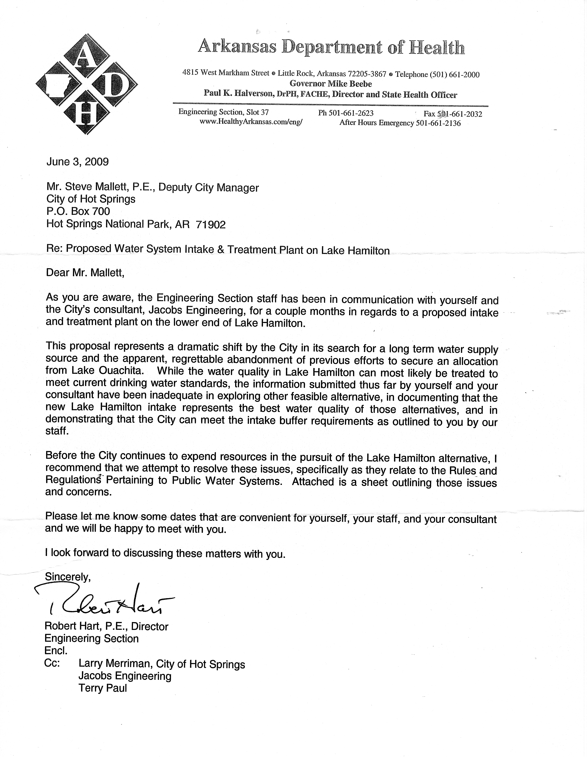

Enclosure to Engineering Section letter of June 3, 2009
City of Hot Springs Proposed Intake & Treatment Plant on Lower Lake Hamilton
Comment Applicable Section & Language of Regulations

1. The proposed intake buffer zone does not meet ADH regulations as applied to similar intakes in the past.
2. The City and its consultant have failed to prepare a proper preliminary engineering report which outlines the entire scope of work including the availability and feasibility of alternatives to the proposed project.
3. The City and its consultant have not provided a,.comparison of the proposed source to other feasible alternatives from an economic, environmental, and water quality standpoint, and have not demonstrated that the proposed source of water is the best of the feasible alternatives.
Section IX Surface Water Supplies B. Watershed and Reservoir Sanitation 3. Ownership of Restricted Zones c. Other Reservoir Sources In the case of large multi- purpose reservoirs developed, owned and operated by the federal government, the water system owner shall effectively control a restricted buffer zone on land around the water intake structure. The extent of this restricted buffer zone will be determined on an individual basis by the Arkansas Department of Health after a sanitary survey of the proposed intake site has been made. All possible sources of contamination are prohibited within this restricted buffer zone.
Section XX. Preliminary Engineering Reports Before detailed plans and specifications are prepared for the construction of new public water systems or major improvements to existing public water systems are prepared, the owner or his authorized agent shall submit to the Arkansas Department of Health a preliminary report containing data and information sufficient for the complete understanding of the proposed work.
Section V Water Quality
B. Approval
.... Production of water that poses no threat to the
consumer's health depends on continuous
protection. Because of human frailties associated
with protection, priority should be given to selection
of the purest source.
Section XXII Engineers' Report B. Surface Water Supply
If a surface supply is proposed, the nature and extent of the watershed with special reference to its sanitary condition and anticipated maximum and minimum water yield shall be fully and explicitly discussed, together with proposed methods and regulations for the prevention of accidental or other pollution.

